**HUD Glasses – Existing Products and Technologies**

* Wearable technology advancements have meant that image-displaying glasses have become a mainstay of commercial technology.
* Utilise different technologies, there is a wide range of applications available which include camera modules.
* Most interface with a smartphone application, which handles connectivity to the outside world using 3G/4G/5G capabilities (end device dependant).

**Technologies**

* 3 main technologies used to generate a displayed image within the user’s line-of-sight.

Transparent display:

* Non-backlight display used in combination with the lens of the glasses. This display normally sits immediately in front of the lens, so prescription does not effect displayed image.
* More common on non-prescription eyewear, as allows for the display to be more flat (curved displays can be less reliable, are more expensive to tool up)
* Image is driven directly to display using common technology such as MIPI DSI due to display size (physically < 2”)

Mirrored HUD:

* Small size TFT (physically ~ 1”), driven using MIPI DSI, located within an enclosed guide channel.
* Image is directed towards a mirror which reflects the image outwards towards a transparent canvas (may be polymer or glass). This canvas must be oriented to allow reflection of the image directly in to the user’s line-of-sight.
* Image is magnified to cover larger capacity of user’s sight area
* This solution requires less set-up cost as standard display product can be used. Mirror/magnifier are relatively low cost to produce or source directly
* More bulky solution as the guide channel is likely to be in addition to the frame of the glasses.

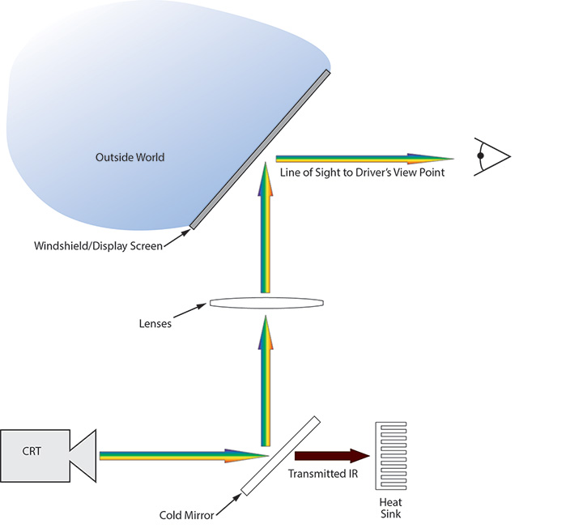

Waveguide HUD:

* Similar technology to fibre-optic, an image is directly transmitted in to a prism which is fully reflective along the direction of the image (within a guide)
* The image is then reflected out the desired location
* This all exists within the lens of glasses, with the display located at any edge (left/right or top/bottom)
* A very compact solution, however image clarity is dependent on the quality of the lens machining and raw materials
* Imperfections within the lens can disturb the image travel which may cause focus issues or even loss of image sections.

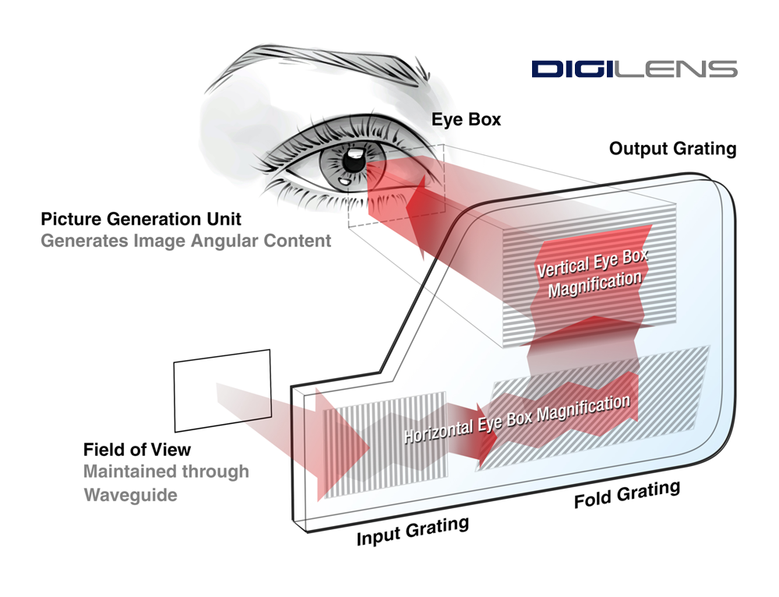

HUD Image Generation Proposal:

Display

Mirror

Microcontroller to drive TFT

MIPI DSI Interface

Magnifier

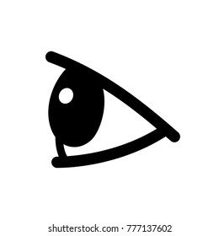

Canvas

Reading list:

<https://uploadvr.com/waveguides-smartglasses/>

<https://www.emf-corp.com/optical-coatings/hot-mirror-vs-cold-mirror/>

<https://prodisplay.com/lcd-led-screens/transparent-screens/transparent-oled-display/>

<https://www.theverge.com/2021/1/11/22225605/vuzix-microled-smart-glasses-next-gen-ar-heads-up-display-ces-2021>

<https://www.mipi.org/specifications/dsi>